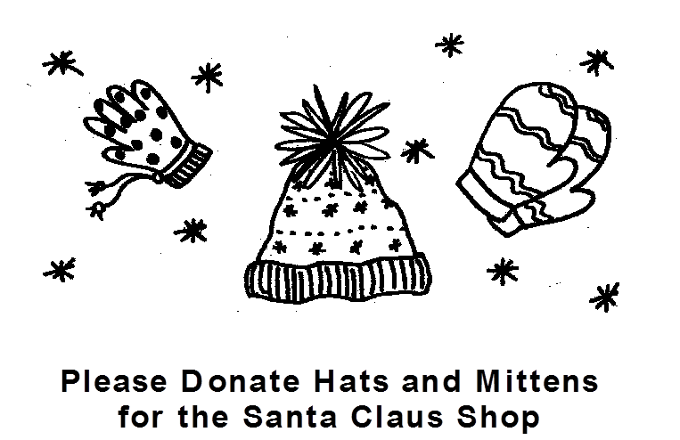

Join us to help others by donating NEW children’s mittens, gloves and hats for the 50^{h} annual Santa Claus Shop. Santa Claus Shop provides deserving neighbors in Summit, New Providence and Berkeley Heights the opportunity to select free, new holiday gifts including clothes, toys, books and housewares for members of their immediate families.

Please place your unwrapped donations in the Santa Claus Shop container in the school’s main entrance now through Friday, November 25th.

Thank you for your generosity!

For more information on volunteer opportunities or to donate, please visit www.summitsantaclausshop.com.

